**Exercise No:**11

**Register No:**1518102067

**Date**:20/11/2020

**Aim:** To write the python program obtain greatest common divisor (GCD) of two given numbers.

**Program:**

def gcd(a,b):

if(a==0):

return a

if(b==0):

return b

if(a==b):

return b

if(a>b):

return(gcd(a-b,b))

else:

return gcd(a,b-a)

a=int(input("Enter first number:"))

b=int(input("Enter second number:"))

GCD=gcd(a,b)

print("GCD is:")

print(GCD)

**LINK:** [**http://103.53.53.18/mod/vpl/forms/submissionview.php?id=326&userid=1682**](http://103.53.53.18/mod/vpl/forms/submissionview.php?id=326&userid=1682)

**Output:**

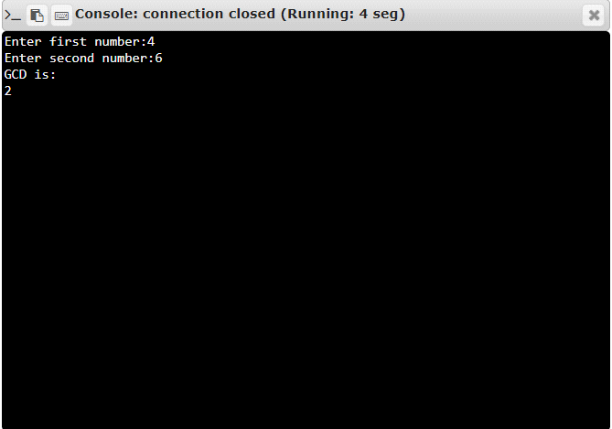

**RESULT:** Thus the program is executed successfully and the output is verified.